**Data visualization**

Visualization allows us visual access to huge amounts of data in easily digestible visuals.

Well designed data graphics are usually the simplest and at the same time, the most powerful.

With the help of visualization, we get well-defined overview of entire data and understand our data in a better way.

Data visualization is used for analysis of data to make future predictions and this is highly used in solving business problems.

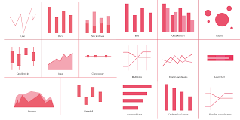

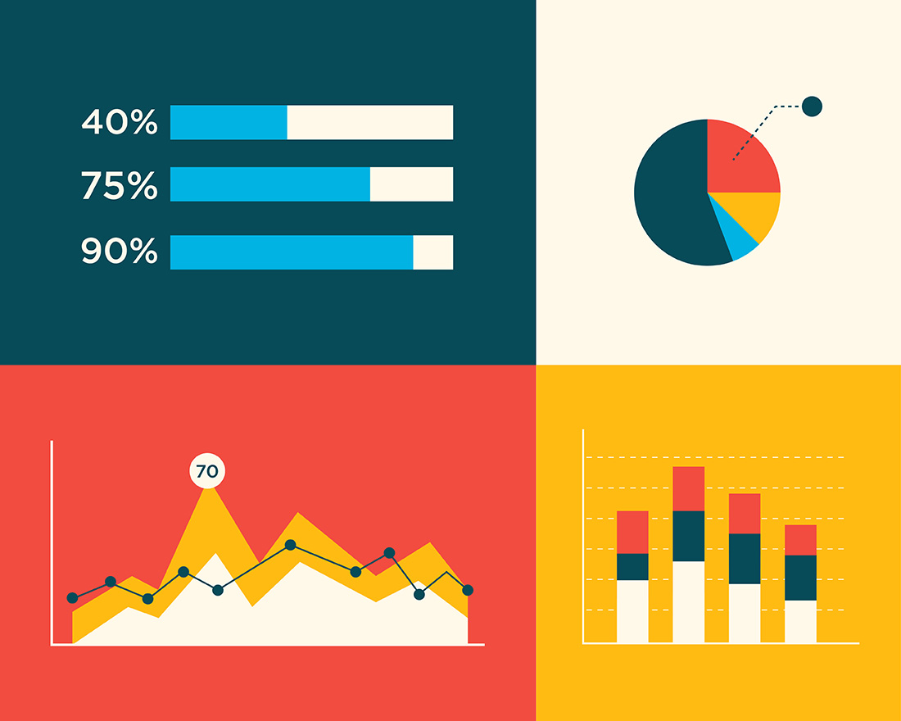

Here data analysis will be so much easier when you plot it and you see the behaviour of data, that is how you can make future predictions.

That is why data visualization is so popular and people have been using it all around the world.

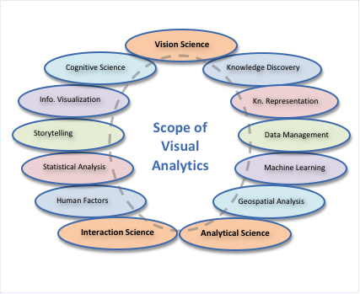

Visual analytics is very beneficial for Decision making and future predictions.

Here we can also get a better sense of risk, because when you can make future prediction correctly, obviously the risk factor go down and this is very much beneficial for your company.

Here risk factor will be low, so here benefit of better financial performance.

**Tableau**

Tableau is data visualization tool, with help of tableau we can easily visualize and understand data.

**Features of tableau**

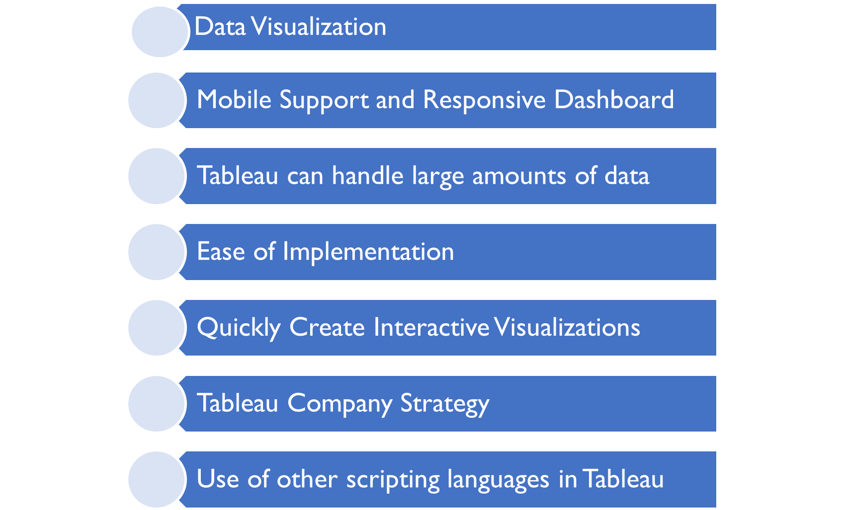

1. Flexibility:

In tableau you can connect any kind of data.

1. Excel file
2. Text file
3. Json file
4. Csv file

In tableau we can play around charts, graphs and visualize your data in many more ways.

It’s take very few seconds for tableau to wait the visualization that we want for our data.

**What is tableau?**

Tableau is a software company which produces interactive data visualization products focused on business intelligence.

Allows to spend more time on data analysis and less time on data wrangling.

**Data wrangling** - The process of removing errors and combining complex datasets.

**Why tableau? (features)**

1.Ease to use

2.Direct connect and go (connect any kind of data source)

3.Perfect mashups (join different type of datasets)

**How to download tableau?**

Tableau public link : <https://www.tableau.com/products/public/download>

File name – sample superstore (excel file)

**How to import file ?**

**Tableau Datatypes ?**

1.Boolean = True/False

2.Date = December 31,2022

3.Date & Time = December 31,2022 01:00:00 AM

4.Text/String = Welcome to tableau

5.Number (Decimal) = 5,000

6.Number (whole) = 5

7.Geographical values = new York, india

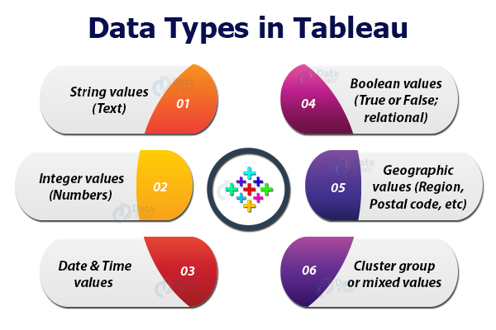

Import order:

# = Number

Abc = String

Calendar symbol = Date

Like that different type of symbols.

**What is Dimensions and Measures?**

When we connect to a data source in tableau, the columns get divided into Dimensions and Measures.

A Dimensions is an independent variable.

A Measures is dependent variable.

**What is Dimensions?**

Dimensions are text data or Dates.

Dimensions are in blue colour.

Ex.

1.City

2.Order date

3.Country

**What is Measures ?**

Measures are numbers.

Measures are in Green colour.

Ex.

1. Profit
2. Sales
3. Discount

**What is marks card?**

With the help of the mark card, we can label our data.

We can colour our data.

**Show me?**

With help of show me, Here they represent how you want to see your data. So there are a number of options available. We can show our data by representing it.

we can visualize data in Pie chart, Bar diagrams. There are different styles of representing in bar graphs or we can also represent it in the geographical map.

When we import dataset, they automatically highlight the data, that you can use to represent it. Here we can see some blurred and some are not.

If it is blurred we can understand, our dataset is not compatible to use these kind of line graphs.

**Tableau – Applying Visualizations**

1. **Bar graph -**  used for continuous value.
2. **Line graph -**  preferred for continuous dimensions.
3. **Dual axis graph –** used to represent two measures together.
4. **Geographical graph -** used to plot measures on geographical map
5. **Area graph – dual axes –** provides better comparison amongst measures
6. **Tree map –**  used to represent quality in nested rectangles.